# [NBC Reveals LAW & ORDER Crossover Key Art](https://www.givememyremote.com/remote/2022/09/01/law-and-order-crossover-poster/)

September 1, 2022 by [Marisa Roffman](https://www.givememyremote.com/remote/author/marisa/)

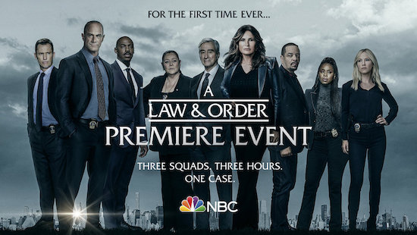

***LAW & ORDER CROSSOVER — Pictured: “Law & Order Crossover” Key Art — (Photo by: NBC)***

NBC has released two versions of the key art for its upcoming [LAW & ORDER franchise crossover event](https://www.givememyremote.com/remote/2022/08/24/behind-the-scenes-photos-and-videos-from-the-law-order-franchise-crossover/).

In the three-hour block, “Gimme Shelter”—which officially air as LAW & ORDER: ORGANIZED CRIME, then SVU, with the mothership closing out the night—”a mysterious young girl is shot in cold blood and Det. Frank Cosgrove (Jeffrey Donovan) teams up with Det. Jalen Shaw (Mehcad Brooks, [in his] first episode) to track down her killer. Capt. Olivia Benson (Mariska Hargitay) and Det. Elliot Stabler (Christopher Meloni) are called in to help when they realize they have more than a typical homicide case on their hands. After uncovering key evidence, Jack McCoy (Sam Waterston) and ADA Nolan Price (Hugh Dancy) seek justice against an international crime ring, but complications threaten the outcome of their case.” The episodes were penned by L[AW & ORDER boss Rick Eid and CHICAGO P.D. boss Gwen Sigan](https://www.givememyremote.com/remote/2022/08/24/law-and-order-svu-organized-crime-crossover-event/); Jean de Segonzac helmed the ORGANIZED CRIME and SVU hours of the crossover, while Alex Hall directed the mothership.

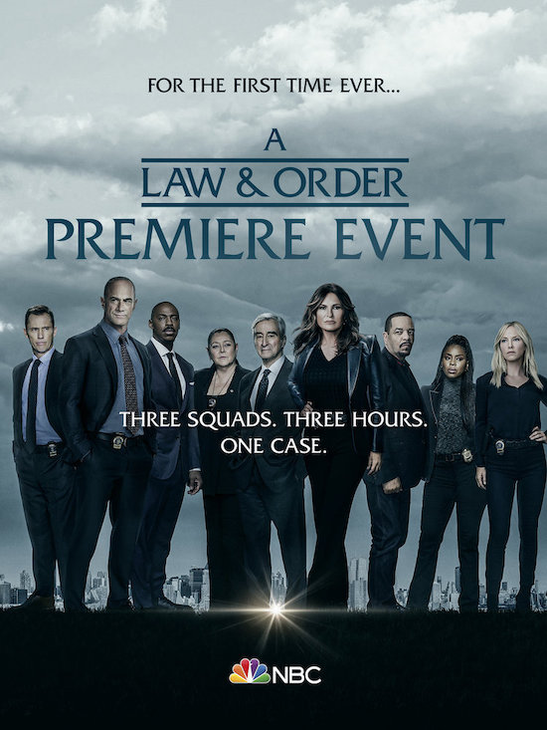

***LAW & ORDER CROSSOVER — Pictured: “Law & Order Crossover” Key Art — (Photo by: NBC)***

Additionally, NBC released a tease for season 24 of SVU:

“Created by Emmy Award-winning producer Dick Wolf, “Law & Order: Special Victims Unit,” now in its 24th season, is the longest-running primetime live-action series of all time.

This hard-hitting and emotional series from NBC’s “Law & Order” brand chronicles the lives of the Special Victims Unit of the New York City Police Department, an elite squad of detectives who investigate crimes of sexual assault, child abuse and domestic violence.

As commander of the SVU, Capt. Olivia Benson (Mariska Hargitay) is a seasoned veteran of the unit who has seen it all. She leads with empathy and professionalism, all the while dealing with her difficult past as a product of rape, and her responsibility as a trailblazer in survivor advocacy, both of which influence the way she relates to the victims and perpetrators of each case. Olivia Benson is the longest-running female character in a primetime live-action television series.

As Benson’s second-in-command, Sgt. Odafin “Fin” Tutuola (Ice T) adds a unique sense of humor and undercover investigative experience, making him a formidable match for any partner. Senior Det. Amanda Rollins (Kelli Giddish) has earned her place as an integral part of the team while facing head-on the emotional toll it takes to work SVU. Det. Joe Velasco (Octavio Pisano) learns the nuanced and sensitive approaches to working with SVU survivors as the newest member of the squad. Assistant District Attorney Dominick “Sonny” Carisi (Peter Scanavino) brings a fresh outlook and distinctive style of investigation to his cases while navigating the politics of the DA’s office.

“Law & Order: Special Victims Unit” is produced by Universal Television, a division of Universal Studio Group, in association with Wolf Entertainment. Dick Wolf is creator and executive producer. David Graziano, Julie Martin, Mariska Hargitay, Norberto Barba, Ken Brown, Arthur Forney and Peter Jankowski executive produce.”